Create user with name and provide sudo access

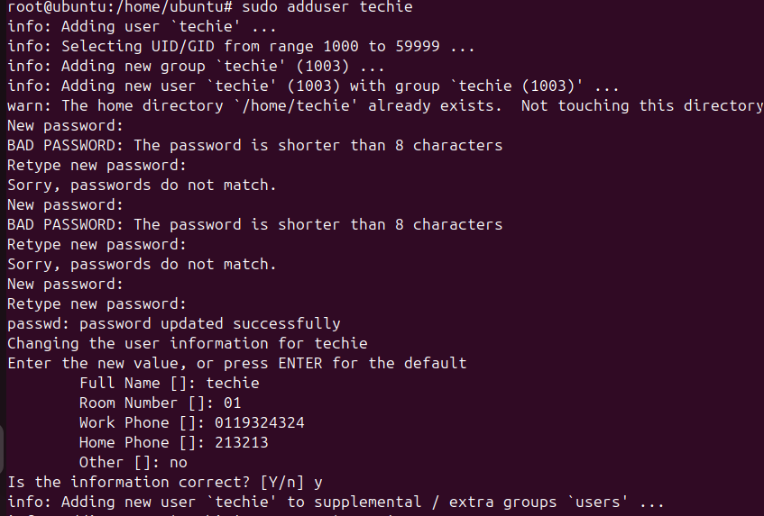

- Sudo adduser < username>
Now set your password , next add ur full name , room number , work phone , home and other
After adding this it ask is information is correct if it correct type (y)
If in case if it wrong just type (N)
- Now the user has been add to our machine

2. Navigate to the home directory
Commands:
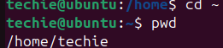
Expected output:
Display /home/techie
Screenshot: terminal showing path
Explanation:
To navigate home direcotory we use command cd ~

3. Create new directory
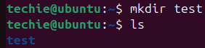
Expected output:
New folder test visible
Screenshot: terminal to check type ls
Explanation :
The mkdir command is create new directory in linux

4. List contents of a directory
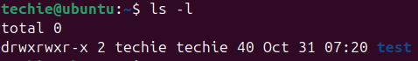
Expected output:
Shown files and directories
Screenshot: output list
Explanation:
The ls command is used to ls in the current directory
5. change the currect directory
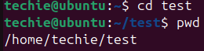
Expected output:
Shown /home/techie/test
Screenshot: path output.
Explaination:
To change currect directory we use command cd( ur directory name ) in my case its test

6. Create a new empty file
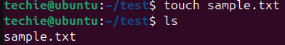
Expected output:
File sample.txt created.
Screenshot: list showing file
Explaination:
To create new empty file you can use touch command with touch command u can create file

7. view contents of a file
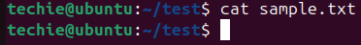
Expected Output:
If empty-no output.
Screenshot: cat command.
Explaination:
To view contents of a file you can cat command to view content of a file

8. copy a file to another location
Expected output:
File coped to /tmp/
Screenshot: command and vefitication
Explaination:
to copy file one location to another you can use cp command

9. move a file to another location
Expected otput:
File movied one directory up
Screen shot: before/after ls
Explaination:
To movie txt from one place to another you can use mv command

10. rename a file

Expected output:
File rename successfully
Screenshot:terminal after ls
Explaination:
We use the mv command to rename a file — for example, mv oldname.txt newname.txt changes the file name.

11. Delete a file
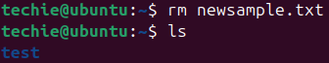
Expected output:
File deleted.
Screenshot:list before/after deletion
Explaination:
To delete a file we use rm command
12. Grant or revoke permissions
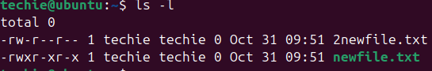
Expected output:
Permission changed
Screenshot:ls –l 2 different txt files
Explaination:
To give revoke permissions we can use command ls –l

13.View current date and time
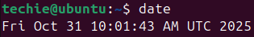
Expected Output:
Current date/time display
Screenshot: output
Explaination:
to view date and time by type date and time u can view it

14. Check system uptime
Expected Output:
Shows time since last reboot.
Screenshot:output
Explaination:
The uptime command shows how long the system has been running, along with the current time and system load.

15. view running processes
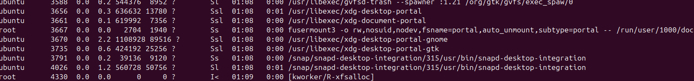
Expected output:
List of running processes
Screen: top few line
Explaination:
The ps command is used to ps on the system, showing process IDs and related details

16. Kill a running process
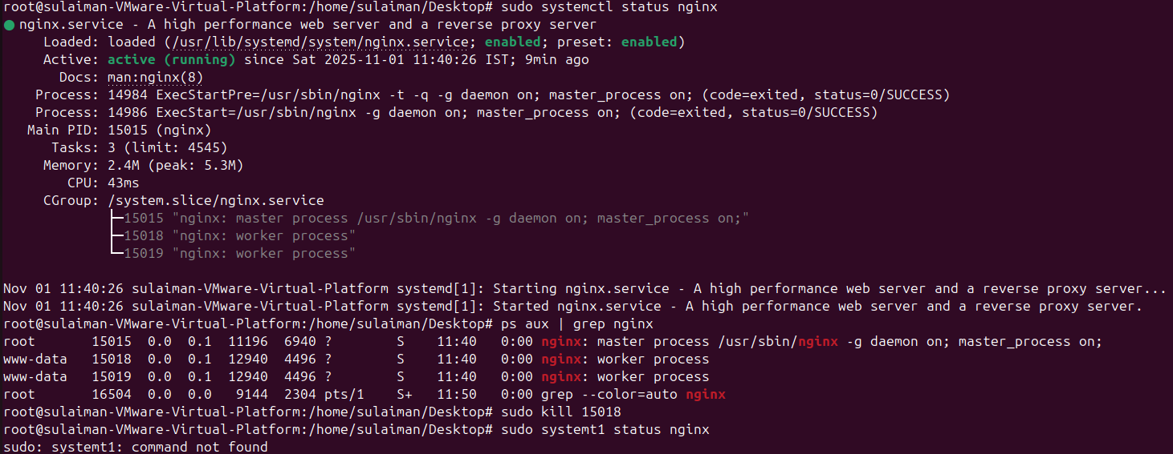
Expected outputs:
Process terminated.
Screenshot:before & after process list
Explanation:
The kill command is used to stop or terminate a running process by its process ID (PID).

17. Install a package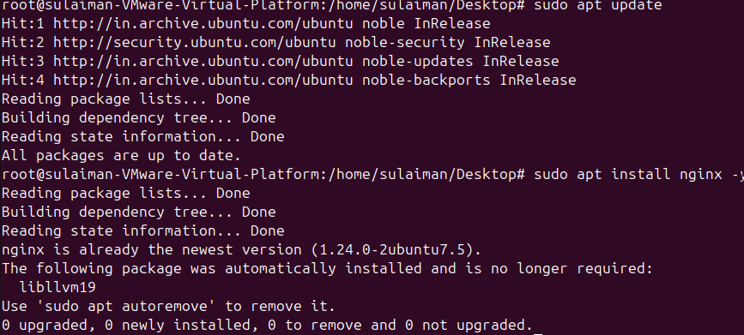
Expected output:
Package installed successfully
Screenshot: installation output
Explanation:
The sudo apt install package-name command is used to pkg install (name)on Ubuntu

18. update system packages
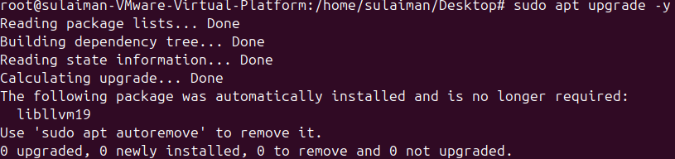

Expected Output:
System packages update.
Screenshot: terminal during upgrade
Explanation:
To update you can use command apt update & apt upgrade

19. create a symbolic link
Expected output:
Symbolic link created.
Screenshot: ls –l output showing link -- arrow
Explaination:
The ln -s target linkname command is used to create a symbolic link, which acts like a shortcut to another file or directory.

20. search for files using find
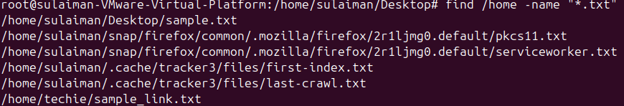
Expected output:
Lists mactching .txt file
Screenshot: output list
Explaination:
The find command is used to search for files and directories in a specified location based on name, type, or other conditions.

21. Search for file using find
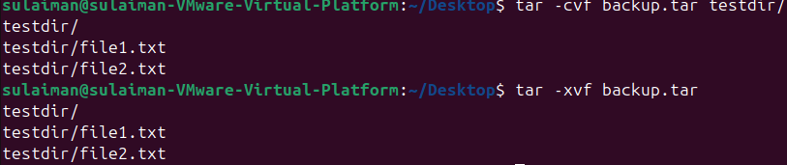
Expected Output:
Tar archive created and extracted
Screenshot: both commands
s
The find command is used to search for files and directories in a specified location based on name, type, or other conditions.
22. Monitor system resource

Expected output:
Live cpu,ram, usage
Screenshot:top or htop screen
Explaination:
By using top or htop you monitor system resource
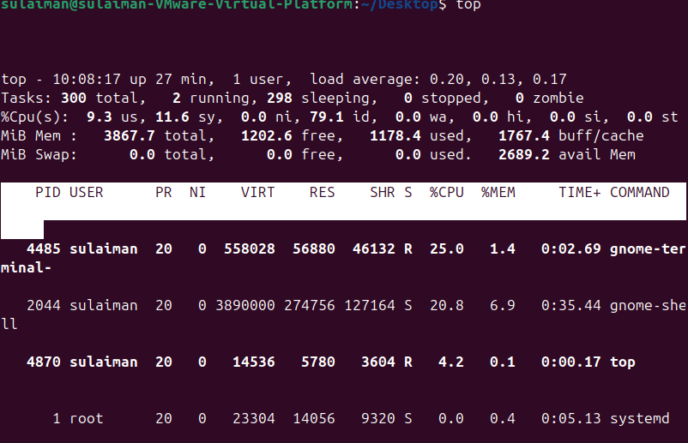
23. create and manage group
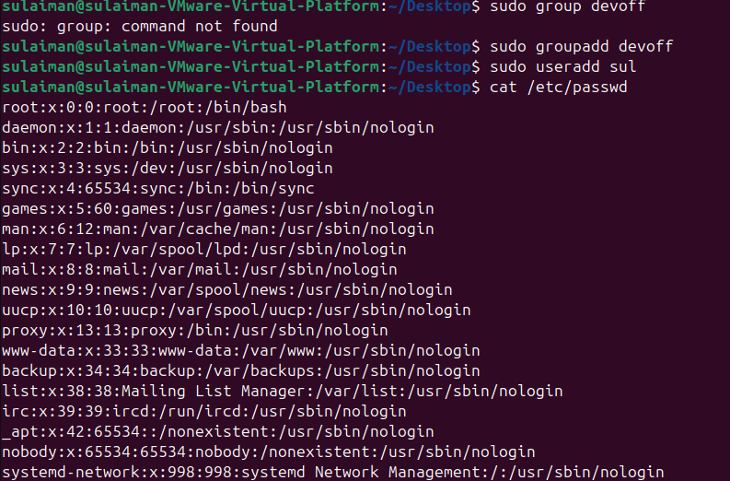
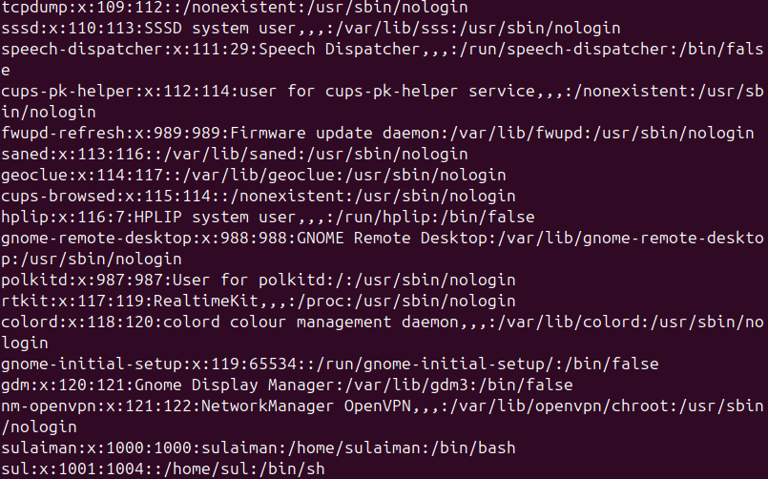
Expected output:
Shows sul added
Screenshot: output
Explaination:
The groupadd command is used to create a new group, and commands like groupdel or gpasswd help manage group memberships

24. SSH passwordless authentication
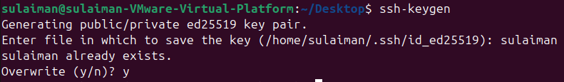

Expected output:
Login:sulaiman
Screenshot: output
Explaination:
SSH passwordless authentication uses SSH keys to connect between systems securely without typing a password each time.

25. Monitor log file
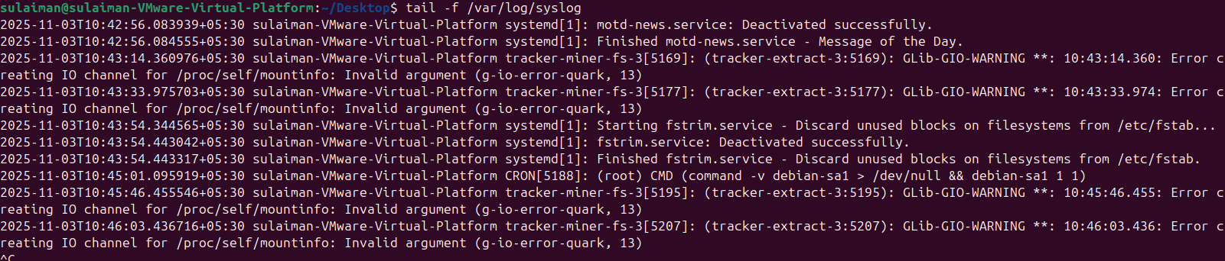
Expected output:
Shows recent log entries
Screenshot:terminal outputs

26. set up web server (Apache)
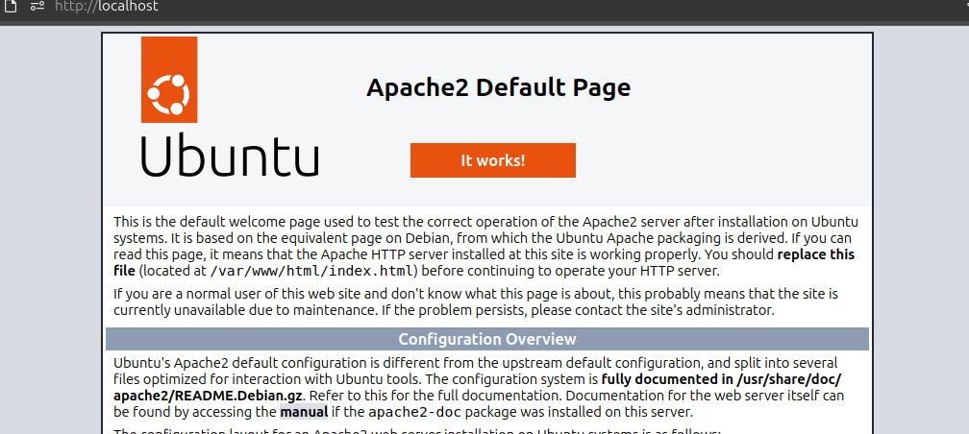

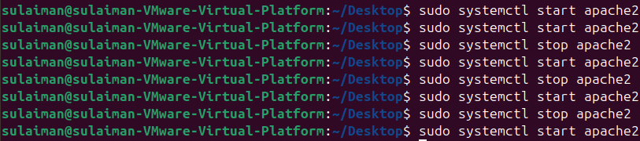
- To install tomcat short step you need follow
- (Sudo apt update) refresh packages list
- (Sudo apt install –y openkdk-11-jdk wget java –version) why : Tom cat needs java.
- (Sudo mkdir –p /opt/tomcat/)
- Why : installation location
- Cd /tmp wget (httpss:downloads.apache.org/tomcat/tomcat-9/v9.0.97/bin/apache-timcat-9.0.97.tar.gaz)
Why: get official tomcat pakage
- (sudo tar –xvzf apache-tomcat-9.0.97.tar.gz) ( sudo mv apache-tomcat-9.0.97/*/opt/tomcat/)
Why:put tomcat file in place
- ( sudo chmod + /opt/tomcat/bin/*.sh)
Why: allow start/stop scripts.
This are few steps to install tomcat installion of server tomcat

Expected output:
http://localhost opens apache default page.
Screenshot: browser showing Apache test page

27. configure and sercure mysql
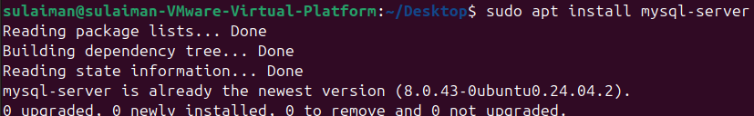

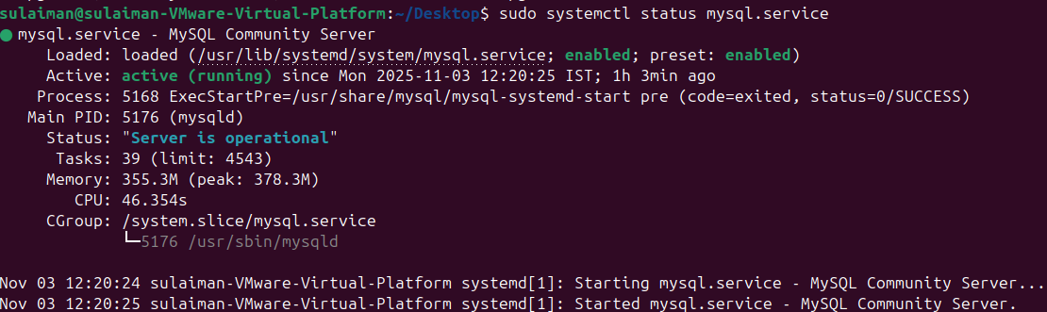

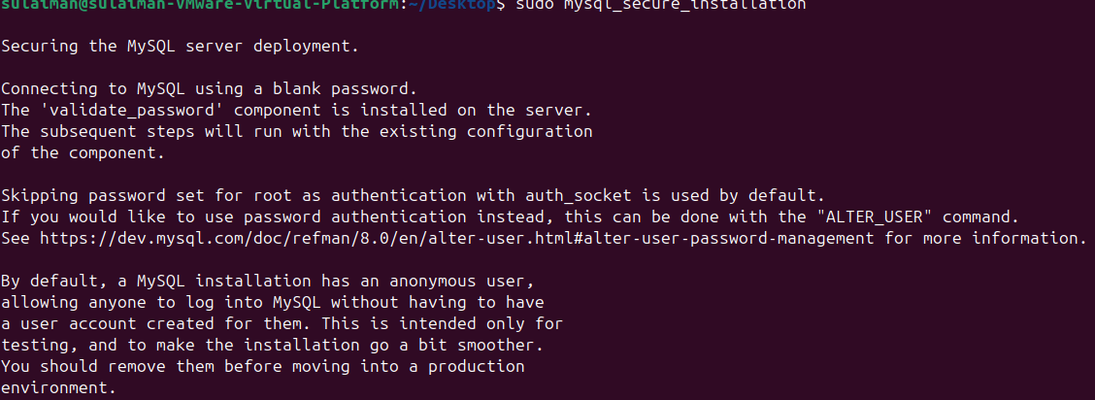
Installing java

Expected output:
Tomcat service running.
Screenshot: terminal + browser showing port 8080

28. set up application server (Tomcat)
Steps you need follow set up tom cat server on ubantu

Tomcat Application Server Setup on Ubuntu

1️ Update System
First, update and upgrade your Ubuntu packages:
sudo apt update && sudo apt upgrade -y

2️ Install Java (Required for Tomcat)
Check if Java is installed:
java -version
If not installed:
sudo apt install default-jdk -y
Then confirm again:
java -version

3️ Create Tomcat Directory
We will install Tomcat inside /opt:
cd /opt
sudo mkdir tomcat

4️ Download Apache Tomcat
Go to Tomcat official site → copy the latest .tar.gz link.
Then use this command:
cd /tmp
curl -O https://dlcdn.apache.org/tomcat/tomcat-10/v10.1.31/bin/apache-tomcat-10.1.31.tar.gz

5️ Extract the File
Extract the downloaded Tomcat package into /opt/tomcat:
sudo tar -xvzf apache-tomcat-10.1.31.tar.gz -C /opt/tomcat --strip-components=1

6️ Give Permissions
Allow execution and set ownership:
cd /opt/tomcat
sudo chmod +x bin/*.sh

7️ Start Tomcat Server
Move into the bin directory:
cd /opt/tomcat/bin
Start Tomcat:
sudo ./startup.sh

Expected output:
Tomcat service running
Screenshot: terminal + browser showing port 8080
29. create service file for tomcat
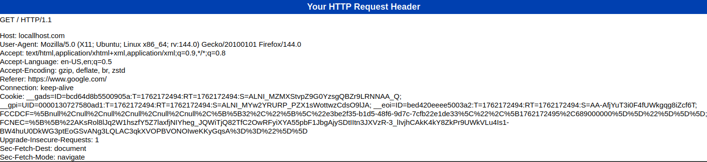

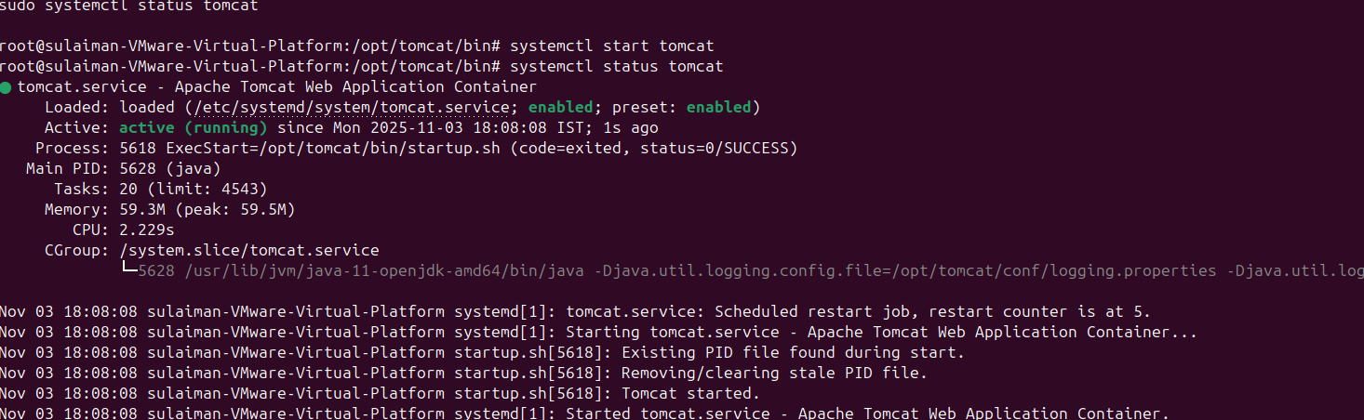

Expected output:
Systemctl status tomcat shows “active (running)”.
Screenshot: service file + status output

30. print specific columns
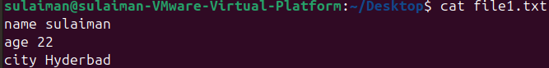

Expected output:
Shows column 1 and 3 only
Screenshot: output

31. grep “error logfile.txt

Expected output:
Show lines containing “error” (the error is in etc directory)
Screenshot: output

32. calculate average or sum
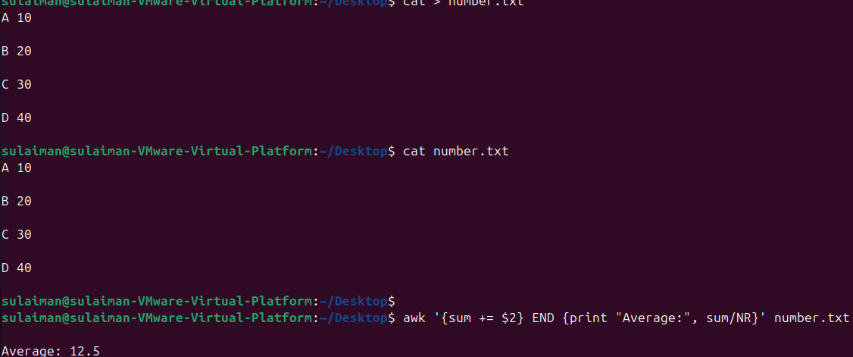

Expected output:
Display calculated average
Screenshot: output.

33. Staring manipulation
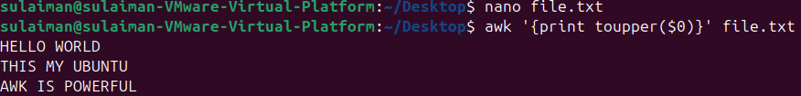
Expected output:
Conert text to uppercase
Screenshot:output ( in nano file.txt inside u edit u message that display on kernel)

34 count occurrences of pattern
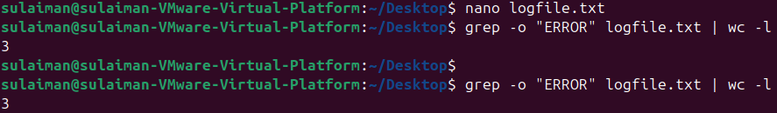

Expected output:
Shows count number.
Screenshot: output. The error is in pattern is 3

35. sort line by field
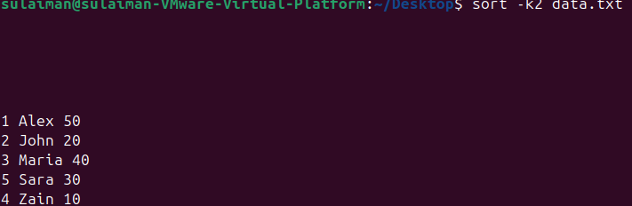

Expected output:
Sorted lines displayed
Screenshot:before or after

36 merge file by common field
join command is used to combine two files based on a common field (like matching words or IDs). It helps merge related data from different files into one file.

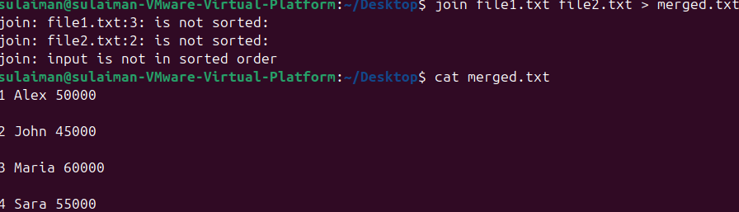
Expected output:
New merged file created
Screenshot: merged output
First u need edittxt file 1 and 2 name, number

37. substitute text using sed
1) Before
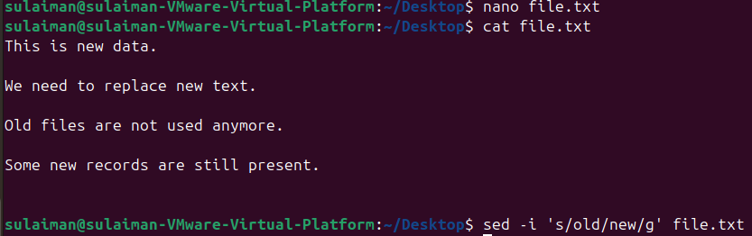
2) After
sed is a stream editor used to find, replace, or delete text directly in files. It helps automate text changes quickly without opening the file manually.
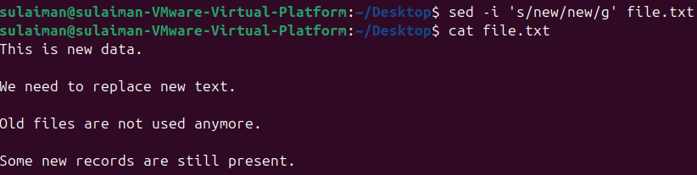

Expected output:
Text replaced
Screenshot; before/after file

38. Delete specific lines
Before
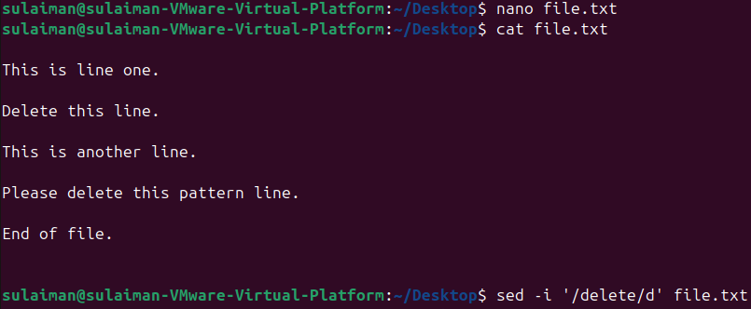

After
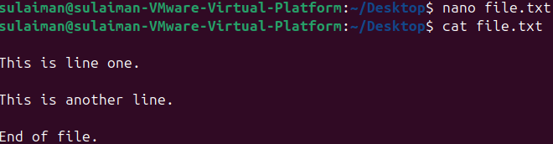
Expected output:
Pattern lines remove
Screenshot: before/after

39. Append or insert text
Before
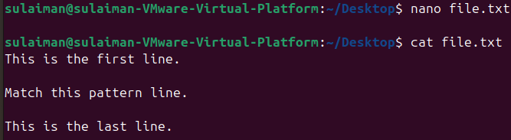

After
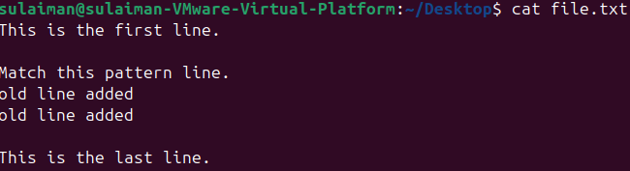
sed '/pattern/a\text' adds a new line of text after every line matching the given pattern in a file.
Expected output:
New line appears after pattern
Screenshot:before and after

40. print only specific line
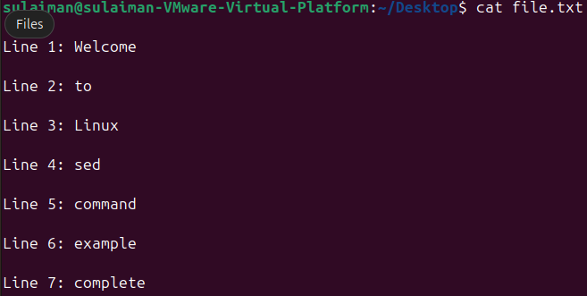

Expected output:
Shows first 7 line
Screen:output

41. copy file from linux to windows
First u need to make create ur sample file in my case im using nano inside in it u can write line that deliver to windows to linux

Windows open cmd (command prompt)
Check your ip simple typing ipconfig
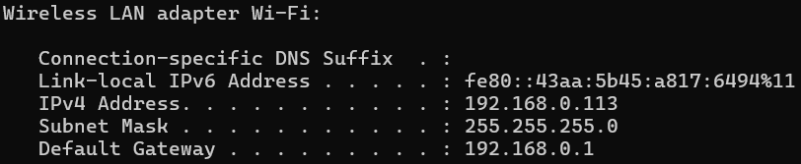
scp file.txt user@192.168.0.1:/Users/user/Desktop

Expected output:
File transferred
Screenshot:scp command success

